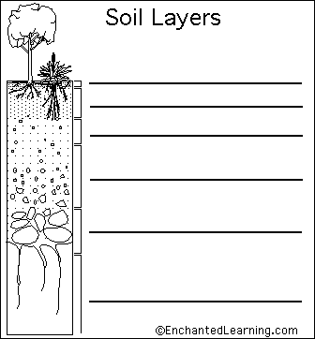

O Horizon - The top, organic layer of soil, made up mostly of leaf litter and humus (decomposed organic matter).
A Horizon - The layer called topsoil; it is found below the O horizon and above the E horizon. Seeds
germinate and plant roots grow in this dark-colored layer. It is made up of humus (decomposed organic matter) mixed with mineral particles.
E Horizon - This eluviation (leaching) layer is light in color; this layer is beneath the A Horizon and above
the B Horizon. It is made up mostly of sand and silt, having lost most of its minerals and clay as water drips through the soil (in the process of eluviation).
B Horizon - Also called the subsoil - this layer is beneath the E Horizon and above the C Horizon. It contains
clay and mineral deposits (like iron, aluminum oxides, and calcium carbonate) that it receives from layers above it when mineralized water drips from the soil above.
C Horizon - Also called regolith: the layer beneath the B Horizon and above the R Horizon. It consists of
slightly broken-up bedrock. Plant roots do not penetrate into this layer; very little organic material is found in this layer.
R Horizon - The unweathered rock (bedrock) layer that is beneath all the other layers.

