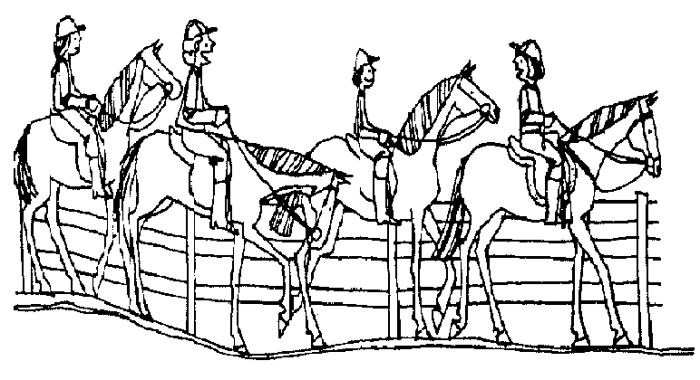
Permission Slip
For
Bruce FFA’s Horse Camping Trip

I give ______________________________________________________________ Permission to attend Bruce FFA’s Horse Camping trip to the Flambeau Mine Recreational area on July 23-24th, 2015. The trip will be chaperoned by Mr. Behrends, and Robin Trott. Parents are encouraged to attend. Meals will be provided on Thursday evening, and Friday morning. Trail rides will begin at 3:00 on Thursday, and the trip will be over at 11:00am on Friday.

Parent Signature: ______________________________________________________ Date: _______________

Emergency Contact Info: ____________________________________________________________________

Permission Slip
For
Bruce FFA’s Horse Camping Trip

I give ______________________________________________________________ Permission to attend Bruce FFA’s Horse Camping trip to the Flambeau Mine Recreational area on July 23-24th, 2015. The trip will be chaperoned by Mr. Behrends, and Robin Trott. Parents are encouraged to attend. Meals will be provided on Thursday evening, and Friday morning. Trail rides will begin at 3:00 on Thursday, and the trip will be over at 11:00am on Friday.

Parent Signature: ______________________________________________________ Date: _______________

Emergency Contact Info: ____________________________________________________________________

