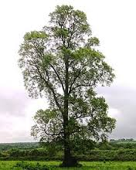

The Dutch elm disease started in the U.S. from diseased elm trees coming from Europe in the 1930s. The worst epidemic of the disease was from 1950 to 1970s. Many people planted Elms in the cities for shade and that’s how the disease got worse. Many trees were wiped out and no elms were safe.

The Dutch elm disease is a fungus that infects the vascular system of trees. This disease will not let the trees get water to the needed limbs and therefore they die. Slowly limb-by-limb the tree is killed away.

The Dutch elm disease can be spread by the Elm bark beetle. This beetle bores itself into the elm tree carrying the fungus on its body from tree to tree and therefore killing many elms. There are a few ways to prevent or help slow down the disease. First of all don’t plant a ton of elm trees in the same area, that’s how the disease got out of control in the first place. If you do plant elm trees then plant ones that are DED tolerant, meaning they can’t get the disease. You can also inject trees with fungicides, trim dyeing branches, and spray elm trees with insecticides to kill the elm bark beetle and its eggs.

<http://na.fs.fed.us/fhp/ded/>

<http://en.wikipedia.org/wiki/Elm>

http://www.youtube.com/watch?v=jzRuVWEx6Mg

Dutch Elm Disease