Bruce FFA
Discovery Degree Application
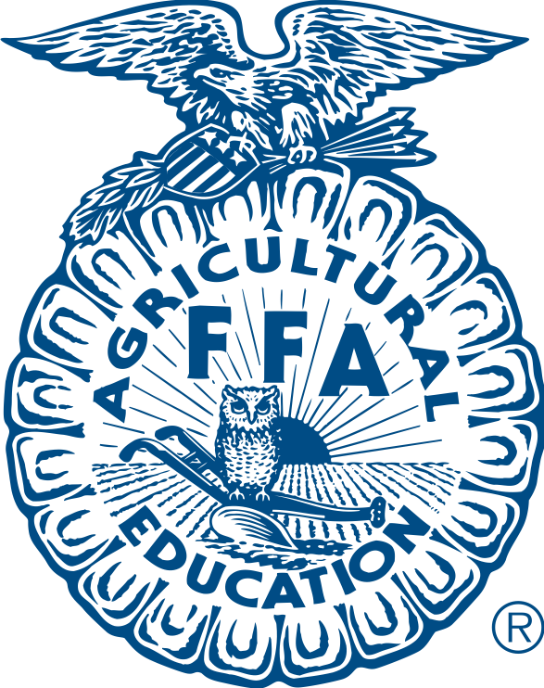

_____I have successfully completed or am currently enrolled in 7th or 8th grade Agriculture class.

_____I am a dues paying member at the local, state and national level

_____I have participated in at least one local chapter activity outside of scheduled class time. Please write the activity you participated in below

_____I have a knowledge of Agricultural careers and opportunities. Write a brief summary of specific real world agricultural careers and opportunities that are available TO YOU. One opportunity must be considered an entrepreneurial opportunity (something you start on your own).

_____I am familiar with the Bruce FFA Program of Activities. As completely as possible, list all of the activities and events Bruce FFA participates in.

I have reviewed this application and certify that the above information is my own work, and is correct.

Name:______________________ Signature:_____________________ Date:___________

Advisor Signature: _____________________________________ Date:_______________

