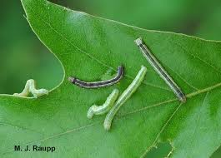

`<https://insects.tamu.edu/fieldguide/cimg293.html>

http://www.youtube.com/watch?v=dHANY10BMhA

by: Ben Adams

http://bugoftheweek.com/blog/2013/12/13/chilly-winter-days-cant-stop-the-fall-cankerworm-ialsophila-pometariai

The cankerworm or more commonly known as the inchworm is known throughout the United States. They are little green caterpillars that measure about one inch long. The males grow wings and turn into moths but the females are wingless.

Cankerworms reproduce by laying eggs in the bark of trees. They eat the broad leaves of any species of trees or bushes but prefer oak and elm the most. These caterpillars don’t really kill trees but just bother them by eating their leaves.

To get rid of cankerworm you can use an insecticide to kill eggs on the tree bark and spray the leaves to keep them from getting eaten.

Cankerworm